**Project Design Phase-II**

**Data Flow Diagram & User Stories**

|  |  |
| --- | --- |
| Date | 26-05-2025 |
| Team ID | LTVIP2025TMID21098 |
| Project Name | Shopsmart: Your Digital Grocery |
| Maximum Marks | 4 Marks |

**Data Flow Diagrams:**

The Data Flow Diagram for ShopSmart showcases the movement of data between different user types (Customers, Store Owners, Admins) and the major system modules such as product listing, cart, order processing, and admin control. It represents how each user type accesses or modifies key data elements like user accounts, product catalogs, orders, and vendor promotions.

Example: DFD Level 0 (Industry Standard)

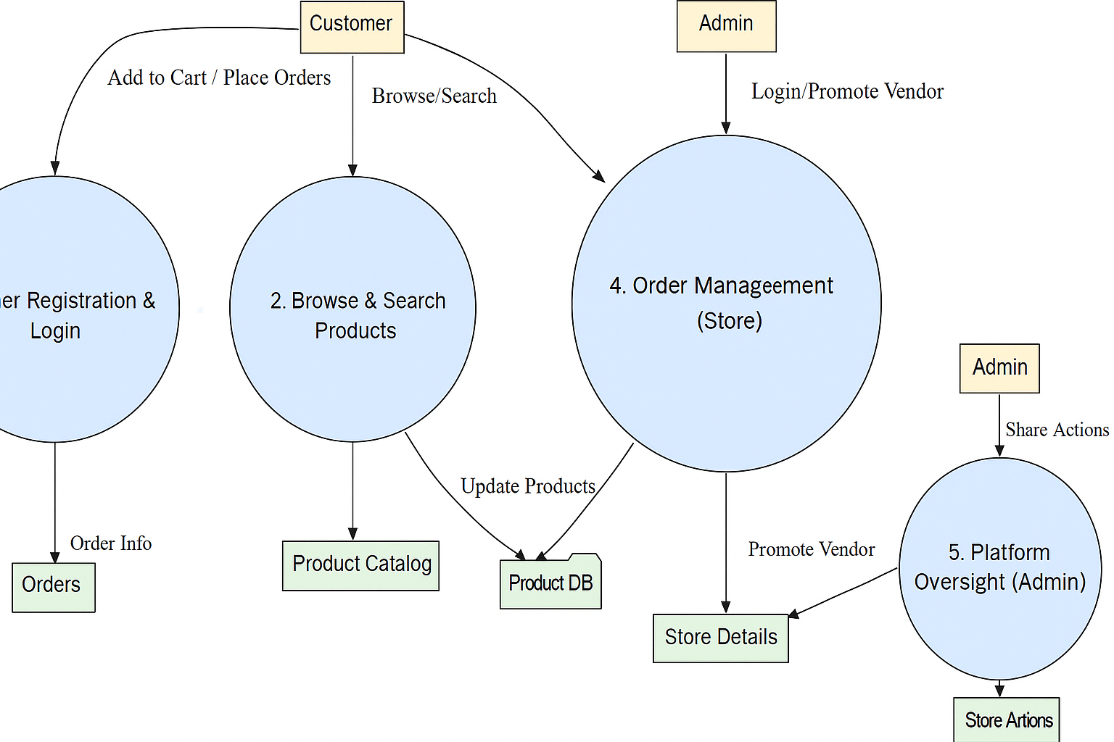

**User Stories**

**🧾 User Story Table – ShopSmart**

|  |  |  |  |  |  |
| --- | --- | --- | --- | --- | --- |
| **User Type** | **Functional Requirement (Epic)** | **User Story / Task** | **Acceptance Criteria** | **Priority** | **Sprint** |
| Customer | User Authentication | As a user, I can sign up and log in securely. | Token is issued on successful login | High | Sprint-1 |
| Customer | Product Browsing | As a user, I can browse and search grocery items. | Filtered results shown based on search | High | Sprint-1 |
| Customer | View Products & Cart | As a user, I can view items and add them to my cart. | Cart shows items with correct total | High | Sprint-2 |
| Customer | Place Orders | As a user, I can place an order from my cart. | Order saved and visible in my orders | High | Sprint-2 |
| Customer | Track Orders | As a user, I can track order status. | Order moves from "Placed" → "Packed" → "Delivered" | Medium | Sprint-2 |
| Store Owner | Store Dashboard Login | As a vendor, I can log in and manage my store. | Dashboard shows product and order info | High | Sprint-3 |
| Store Owner | Manage Products | As a vendor, I can add/edit/delete grocery products. | Product list updates in real-time | High | Sprint-3 |
| Store Owner | Manage Orders | As a vendor, I can update order statuses. | Status change reflects in user tracking | Medium | Sprint-3 |
| Admin | Admin Login | As an admin, I can log in and manage the platform. | Admin panel loads with analytics | High | Sprint-4 |
| Admin | Vendor Promotion | As an admin, I can promote stores to homepage. | Featured vendors update for users | Medium | Sprint-4 |